How can I connect to a wireless network?
This article will guide you on how to connect your wireless devices to a wireless network.
Note: Before connecting to the wireless network, make sure you are clear about the following information:
i. Wireless network name (SSID)
ii. Wireless password (Security Key/Pass phrase/Key)
For instructions on finding out the SSID and wireless password, click here.
Select your computer's operating system from the following list for instructions.
Windows XP
Windows 7/Windows Vista
Windows 8
Mac OS X®
iOS

- Windows XP
Step 1:
Right-click on the Wireless Connection icon at the bottom-right corner of your screen and select View Available Wireless Networks.
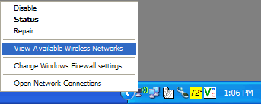
Step 2:
Select your wireless network name (SSID) from the list then click Connect. If the computer is not detecting any signal, click Refresh network list on the top-left corner.
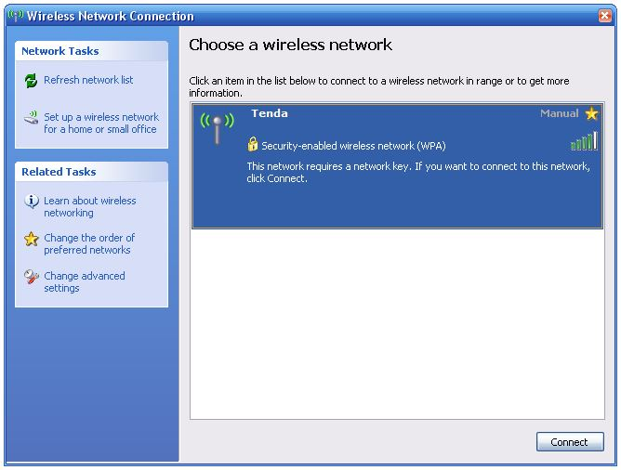
Step 3:
Enter and confirm your wireless Security key/Pass phrase/Key, click Connect.
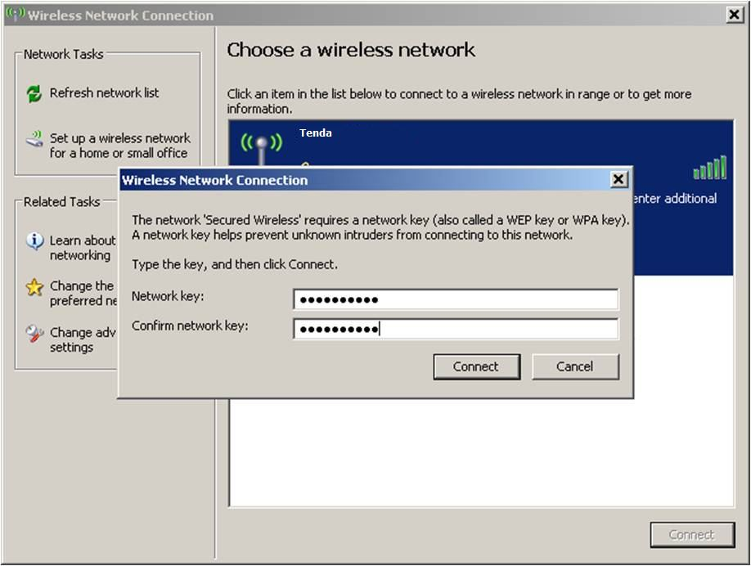
Note: If your network is unsecured, your wireless devices will automatically be connected to the wireless network without entering a security key or password.
Step 3:
Windows will verify the password and, if you entered correctly, your Windows XP computer should now be able to connect to the wireless network.
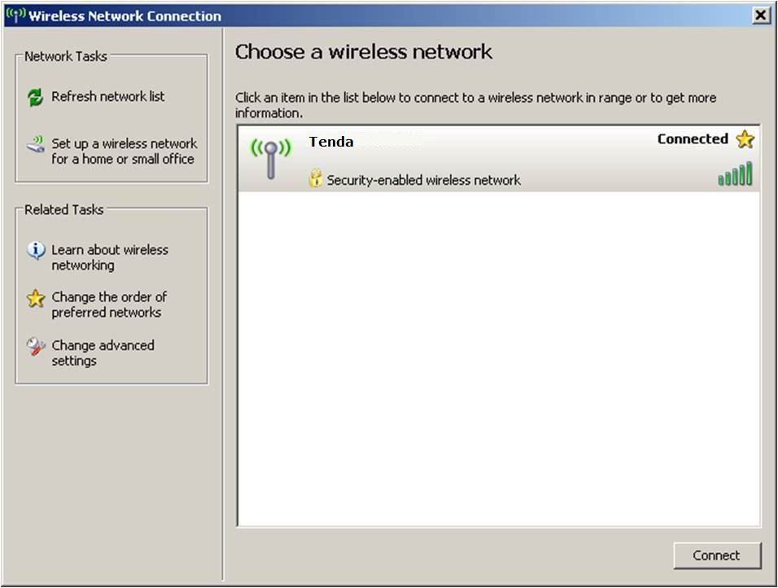
- Windows 7/ Windows Vista
Step 1:

Click the Network icon at the bottom-right corner of your screen and select your wireless network name (SSID). Click Connect.
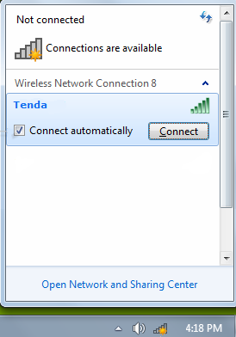
Step 2:
Enter your wireless Security key/Pass phrase/Key in the blank and click OK.
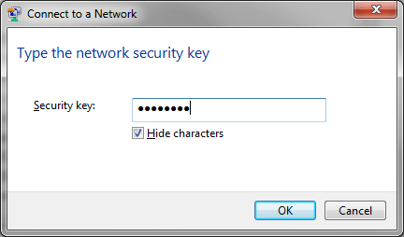
Note: If your network is unsecured, your wireless computer will automatically be connected to the wireless network without entering a security key or password.
Step 3:
Windows will verify the password and, if you entered correctly, your Windows 7/Windows Vista computer should now be able to connect to the wireless network.
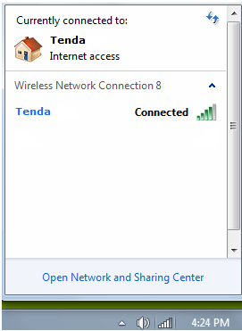
- Windows 8
Step 1:
If you are using a PC, move the mouse to the bottom or top right corner of the screen and select the cog icon labelled Settings.
If you are using a tablet, swipe left from the right side of the screen and select Settings.
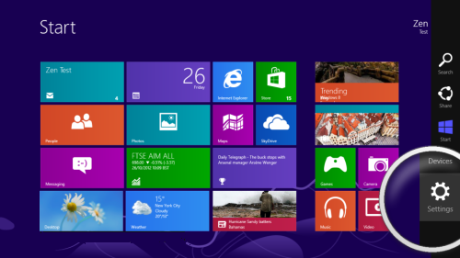
Step 2:
Select the wireless icon.
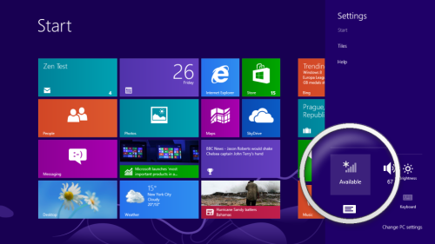
Step 3:
Select your wireless network from the list to connect.
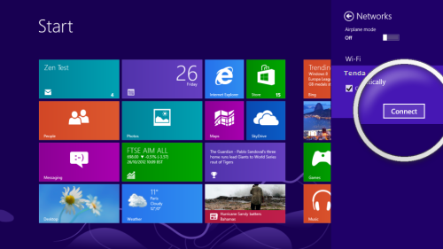
Step 4:
Enter your wireless Security key/Pass phrase/Key if prompted and select Next to connect.
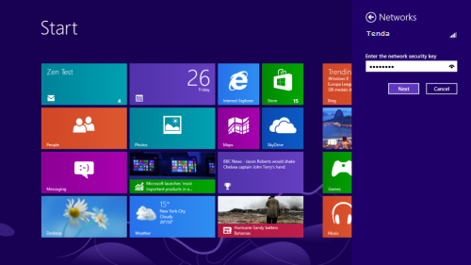
Step 5:
Windows will verify the password and, if you entered correctly, you will be connected to the Wireless network.
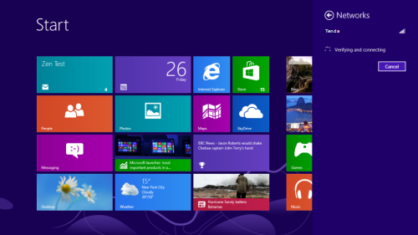
- Mac OS X ®
Step 1:
Click on icon, then select System Preference.
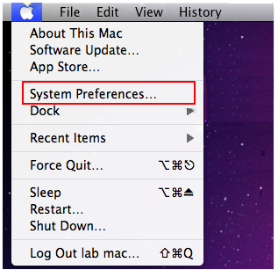
Step 2:
Click on Network icon.
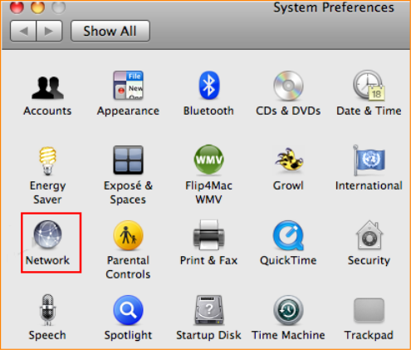
Step 3:
i. For OS X® Snow Leopard 10.6.1
Select Airport and click Network Name drop-down menu to select your desired wireless network.
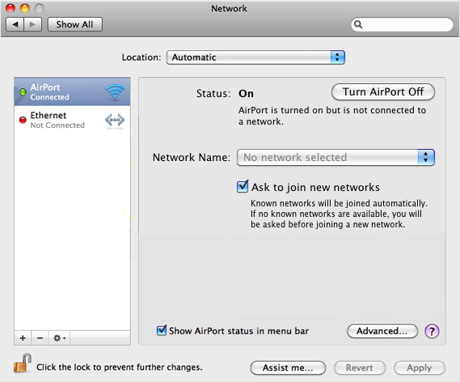
ii. For OS X® Lion/OS X® Mountain Lion 10.8
Select Airport and click Network Name drop-down menu to select your desired wireless network.
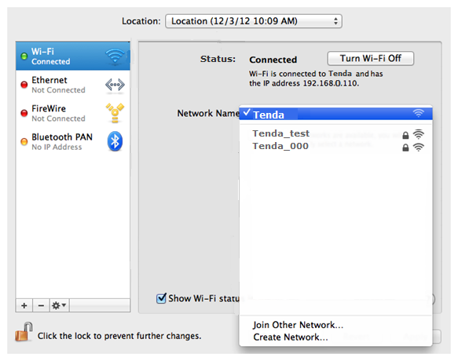
Step 4:
Enter the wireless Security key/Pass phrase/Key if prompted. If you want to connect to the network automatically the next time the network is in range, click Remember this network. Once done, click OK.
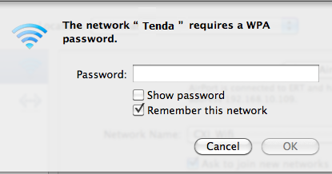
Step 5:
Click Apply to connect to the network.
- iOS
Step 1:
Tap Settings then select Wi-Fi.
When Wi-Fi is on, your device will automatically search for available Wi-Fi networks. Tap your desired Wi-Fi network and connect to it.
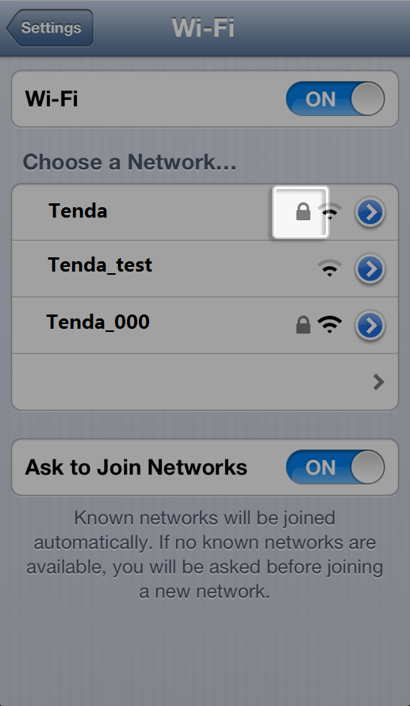
Step 2:
Enter the wireless Security key/Pass phrase/Key in the blank if prompted.
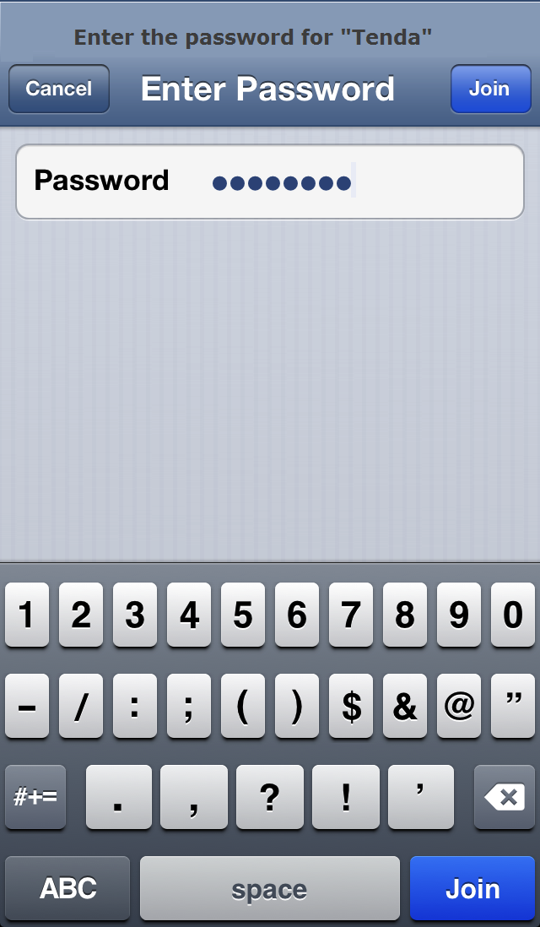
Step 3:
Tap Join.
Note: When your device is connected to a Wi-Fi network, a checkmark will appear to the left of the network name. The Wi-Fi logo will also appear in the status bar at the top left of your display.

